## **CS301 Assignment 3**

## **Ataollah Hosseinzadeh Fard (ID: 28610)**

## **20 November 2022**

# **Problem 1**

Insertion of nodes in RBTs, cost O (log n) in worst case. For calculation of black heights, we only look for its black children, so we won’t iterate to almost all the nodes, while for insertion we iterate to all, so this augmentation won’t cost more than insertion in worst case.

## **Problem 2**

For the calculation of depths, unlike black heights, we must iterate to all the nodes so it will take O(n). And augmenting depths to nodes, will increase the cost of insertion in worst case from O (log n) to O(n).

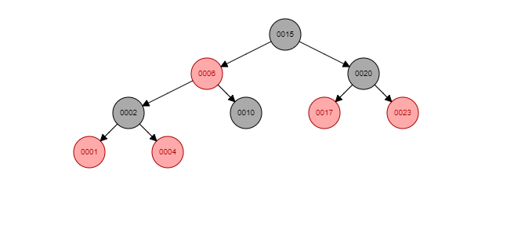

Step 1) our base tree example

Step 2) we add 3 to tree

Step 3) due to RBT constraints it must reshape

After step 3, all of depths except depth of “10” has changed, so to maintain RBT constraints we spent almost O(n).